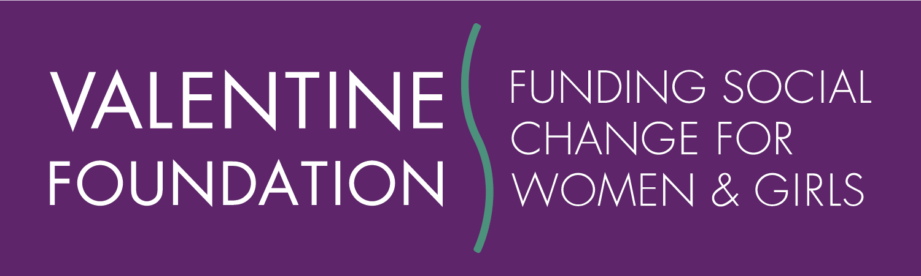
The Social Change Indicators Matrix
Indicator of Social Change Impact | Definition of Shift | Typical  Strategies/Activities Linked to the Shift | Scale of Influence/ Resources Required (time and money)
Shifts in Definitions  The issue is defined differently in the community or larger society | An issue or idea is given new meaning. The community or society sees the issue differently as a result of your work (i.e. rape is understood as an act of violence with legal and civil consequences, not a sexual transgression). | Research, documentation of actual experiences, articulating concepts through writing and/or presentations. | Potential to be large and profound—locally and globally. Sometimes small resources can spark a change. Combining shift #1 and #2 can be effective for accomplishing “buy-in” of new definitions. One-time funding of research/ dialogue can sometimes result in new definitions.
Shifts in Engagement  People in the community or larger society are more engaged. | More people are engaged in an idea of action as a result of your work. Ideally, enough people get involved that they are noticed, voices are heard, i.e. a critical mass is reached, e.g. individuals from groups coalesce for regional impact and numbers of people and organizations make a difference. | Community-based organizing and public education (including media education); media campaigns; networking; supporting a group to find collective strength or identity, etc. Example: MEN Can initiative to engage anyone who identifies with masculinity as advocates against interpersonal violence. | Potential to be large and profound, especially when “critical mass” is defined more explicitly to match the vision or goal. Usually requires large financial resources and multiple years of attention to assist organizing efforts, institutional coalitions or development of intermediaries and networks, often including media strategies.
Shifts in Policies  An institutional, organizational or legislative policy or practice has changed. | Organizational, local, regional, state, national or international policy or practice has changed to better serve social change ideals (e.g. specific laws change and/or institutional systems change or practices change). | Public policy reform, education and interaction with policy and system level decisionmakers. Example: Education Law Center’s project to promote innovative policies and practices that decrease Black girls’ disproportionate presence in the school-to-prison pipeline. | Potential to be large-scale if change occurs at state or national policy levels; local systemic change schools, courts, etc. can also be important. Usually requires multiple years of investments and a variety of approaches.
Current Position Maintained  Past gains have been maintained. | Earlier progress on issues is maintained in the face of opposition (e.g. | Strengthen organizations and leaders and their ability to withstand backlash and resistance to change. | Often the work is complex and requires the interactions of people from many levels, including community-based. Resources needed depend on the scale of the resistance effort. Example: Women’s Law Project operating fund.

Adapted by The Valentine Foundation from the tool developed by Stephanie Clohesy of Clohesy Consulting, based on WFN’s Making the Case tool. Updated in November 2019.

